

Standardized Monitoring Strategies for Burrowing Owls on DoD Installations

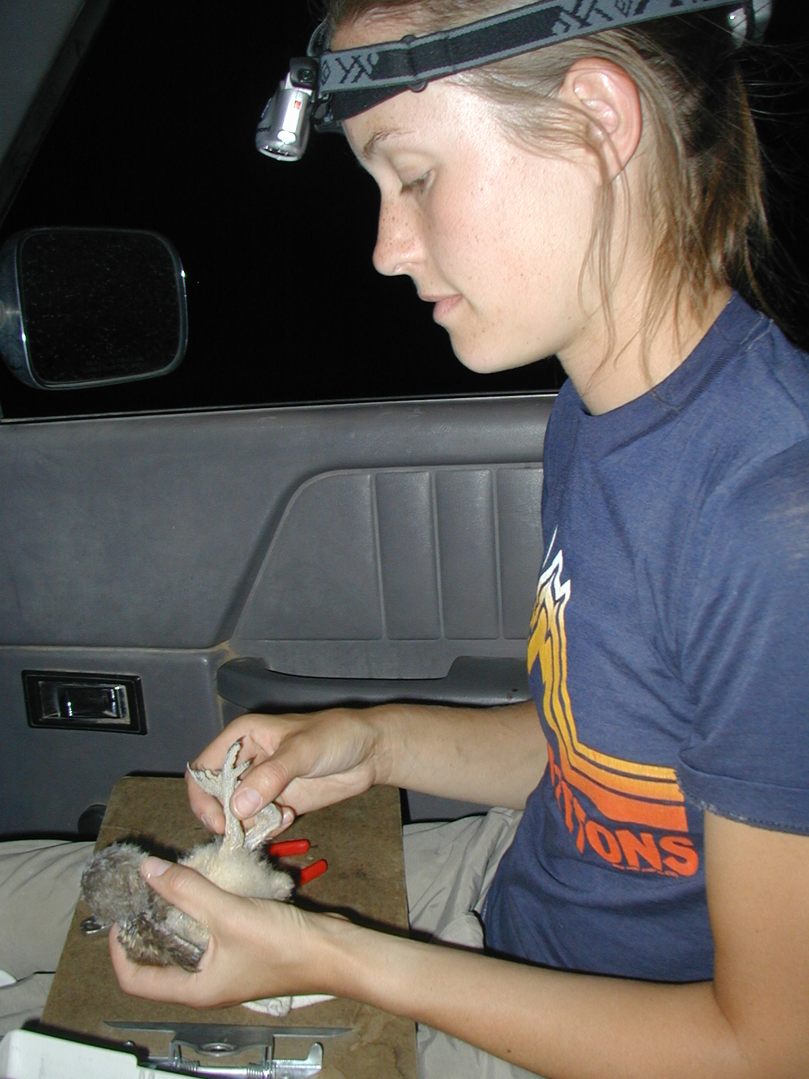
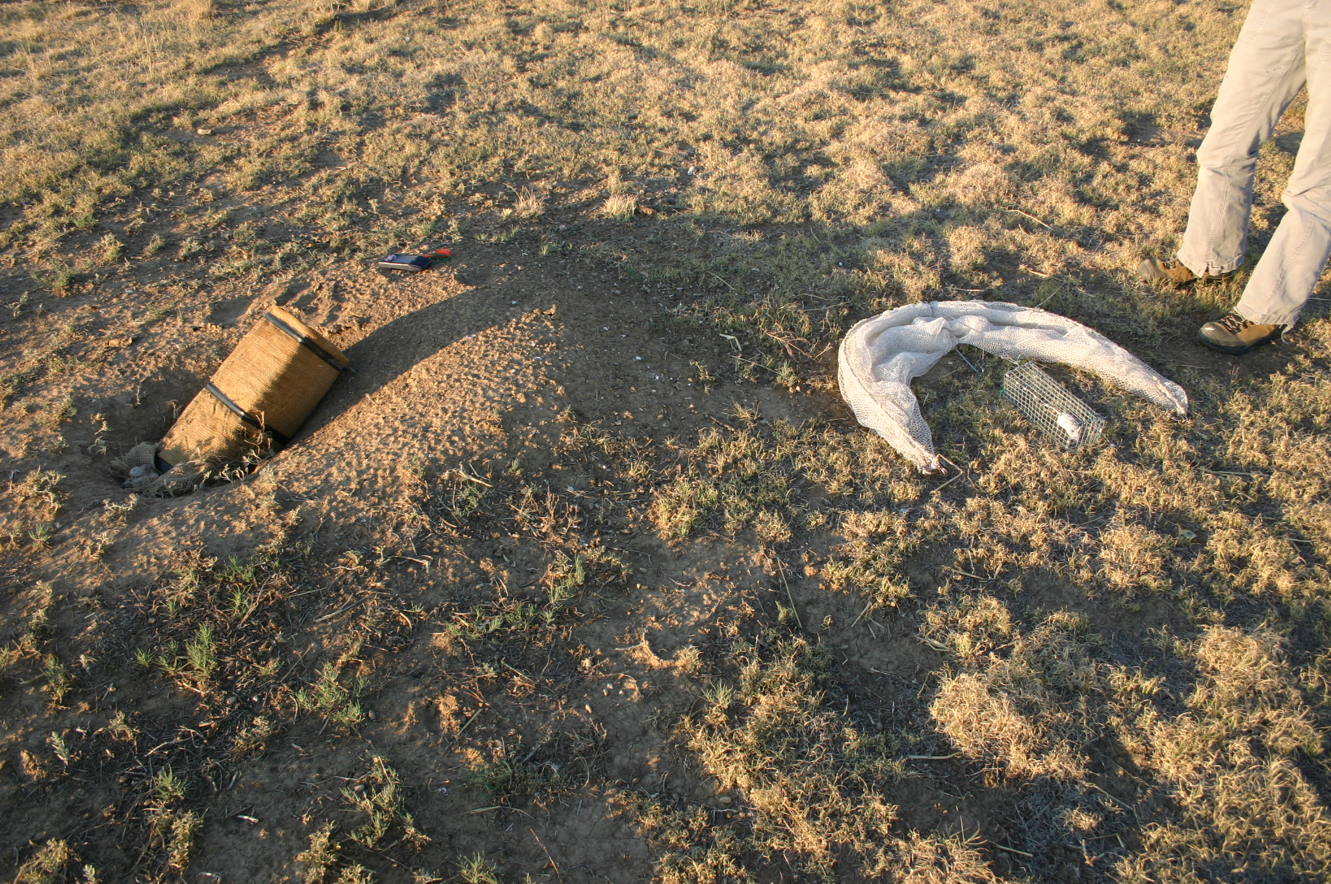

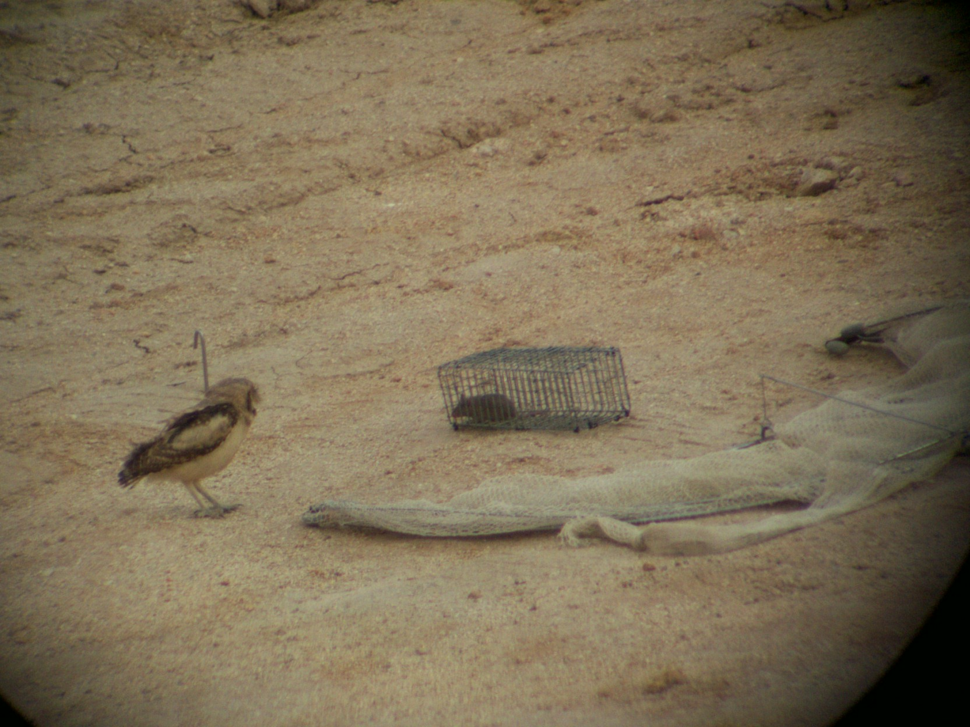

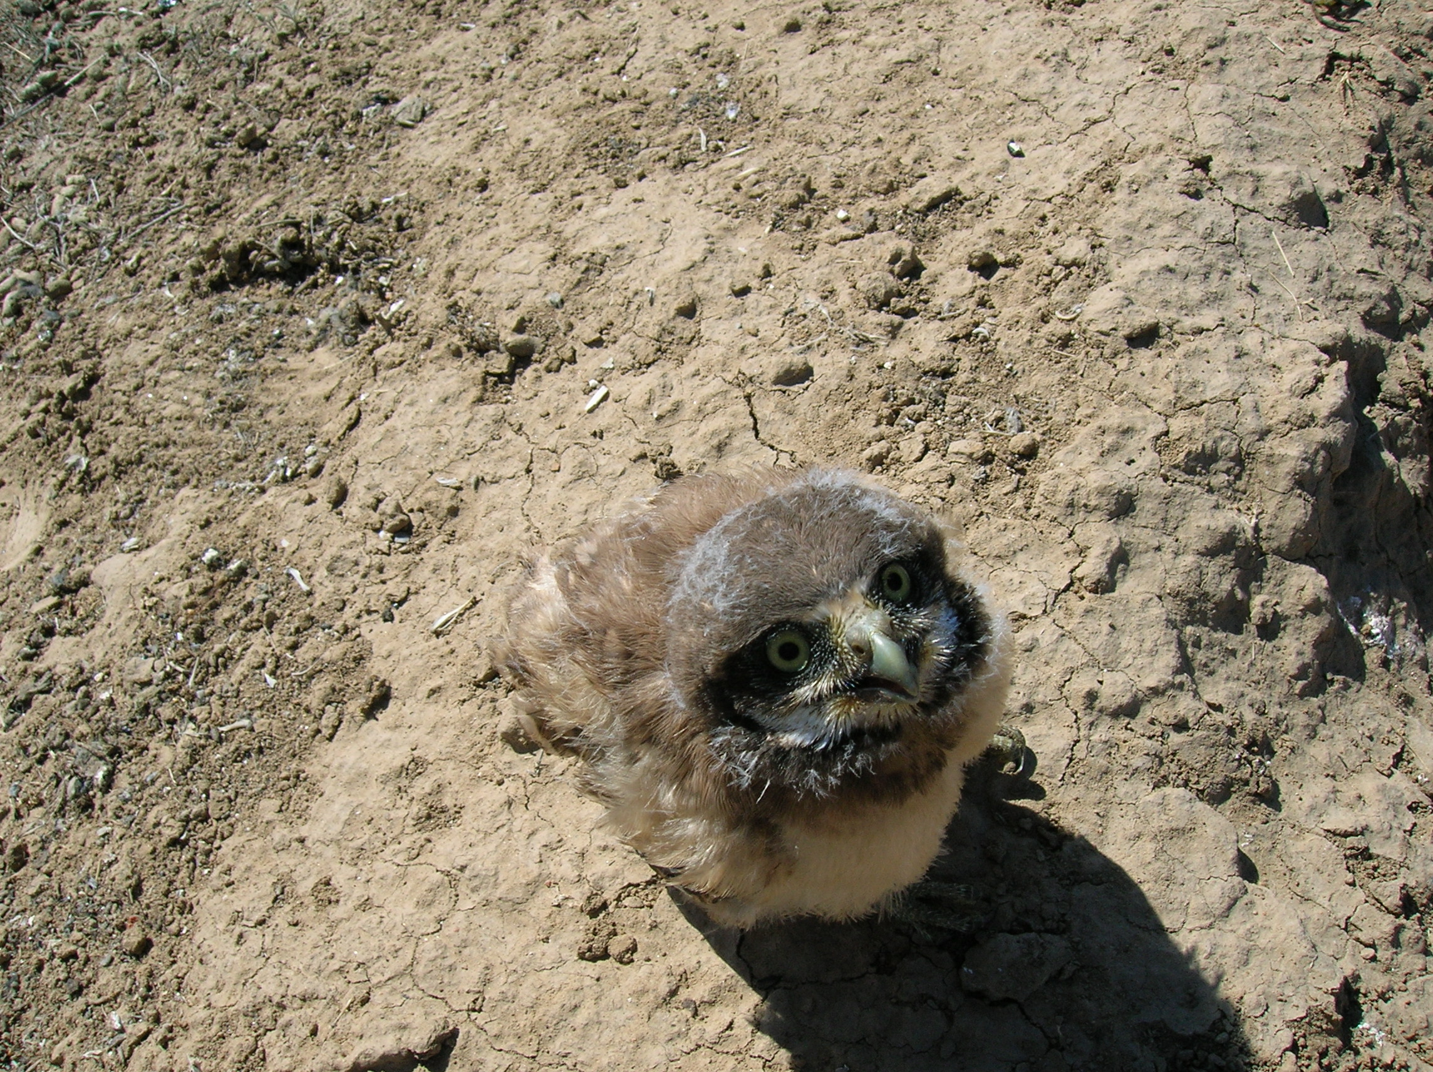

V. Garcia
C. J. Conway
L. A. Ellis
C. P. Nadeau

Arizona Cooperative Fish and Wildlife Research Unit

Table of Contents
Foreword 3
Standardized Roadside Survey Protocol 4
Protocol for Recording Roadside Survey Data 9
Nest Visit Protocol 11
Banding Protocol 18
Protocol for Recording Bands 20
Guide to reporting ACRAFT bands 21
Protocol for Recording Banding Data 22
Morphological Measurements of Burrowing Owls 24
Brood Patch Picture 25
Protocol for Recording Trapping Log Data 27
Quick Reference for Codes and Acronyms on Datasheets 30

Foreword

Burrowing Owls (Athene cunicularia) were once a common breeder in grasslands and deserts throughout the western U.S. and Canada. However, some populations have declined and Burrowing Owls have been extirpated from areas on the western, northern, and eastern periphery of their breeding range. Habitat loss and fragmentation due to agricultural or urban development, the reduction of prairie in the United States, and the control of burrowing mammals such as prairie dogs (Cynomys spp.) and ground squirrels (Spermophilus spp.) are thought to be the causes for the decline in Burrowing Owls (Desmond and others 2000; Klute and others 2003; Sheffield 1997). Due to concerns about persistence of remaining Burrowing Owl populations, Burrowing Owls are now federally endangered in Canada, and are listed as a Species of National Conservation Concern in the U.S. (US Fish and Wildlife Service 2002).
Despite the declines in some portions of their range, Burrowing Owls appear to be increasing in other areas. One possible explanation for this paradox is that Burrowing Owls are becoming less migratory; owls which once migrated to northern breeding locations during the summer are becoming year-round residents in the southwestern U.S. and northern Mexico. In other words, breeding owl populations might be redistributing rather than declining. If this hypothesis is correct, it has implications for the validity of current or future Burrowing Owl listing petitions and implications for the effectiveness of different conservation and management efforts. Burrowing Owls have been reported on many DoD installations in the southwestern U.S., and therefore the DoD may play a key role in the maintenance or recovery of Burrowing Owl populations if declines continue. However, we currently lack information on the extent to which Burrowing Owl populations on DoD installations are self-contained and how much dispersal occurs among locations. In 2005, we initiated a project with support from the DoD Legacy program to help fill these needs. We are using stable isotopes of owl feathers, genetics from blood samples, and radio telemetry to quantify the importance of DoD lands to Burrowing Owl populations in the region, document the extent to which Burrowing Owls disperse between populations, and quantify land-use of migrating and wintering owls in the region. We are working with DoD installations in the western U.S. that have records of Burrowing Owls to test this hypothesis and to develop a coordinated, multi-agency program to help determine the extent to which Burrowing Owl populations are redistributing throughout North America.
As part of this project, we developed the following protocols for monitoring Burrowing Owl populations on DoD installations. The level of monitoring effort will undoubtedly vary among DoD installations, but these protocols provide a complete package such that each installation can use some or all of these protocols depending on their own needs or goals. We provide information for conducting standardized roadside surveys, conducting nest visits (intense monitoring), and banding Burrowing Owls. These protocols can be used singly or in combination. Additionally, natural resources staff may choose to decrease (or increase) the suggested frequencies of tasks depending on their particular programmatic goals. This project is funded by the following: DoD Legacy Resource Management Program, U.S. Department of Energy, U.S. Fish and Wildlife Service, U.S. Environmental Protection Agency, National Park Service, Sonoran Joint Venture, World Wildlife Fund, University of Arizona, Canadian Wildlife Service, University of Alberta, National Council of Science and Technology (Mexico), T&E, Inc., DSCESU.

Desmond MJ, Savidge JA, Eskridge KM. 2000. Correlations between burrowing owl and black-tailed prairie dog declines: A 7-year analysis. Journal of Wildlife Management 64(4):1067-1075.
Klute DS, Ayers LW, Green MT, Howe WH, Jones SL, Shaffer JA, Sheffield SR, Zimmerman TS. 2003. Status Assessment and Conservation Plan for the Western Burrowing Owl in the United States. Washington, DC: US Department of Interior, Fish and Wildlife Service. FWS/BTP-R6001-2003.
Sheffield SR. 1997. Current status, distribution, and conservation of the Burrowing Owl (Speotyto cunicularia) in Midwestern North America. In: Duncan JR, Johnson DH, Nicholls TH, editors. Biology and conservation of owls of the Northern Hemisphere, USDA Forest Service, General Technical Report NC-190. St. Paul, Minnesota: North Central Forest Experiment Station. p 399-407.
US Fish and Wildlife Service. 2002. Birds of Conservation Concern 2002. Arlington, Virginia: Division of Migratory Bird Management. 99 p.

Standardized Roadside Survey Protocol

The goal of these surveys is two-fold: to locate as many owls as possible, as quickly as possible; and to establish a standardized, repeatable survey protocol with high detection probability, low (temporal) variation in detection probability, and low observer variability.

Systematic Survey Routes

Surveys should be conducted periodically (e.g., every morning, every morning and evening, once per week, twice per week) and should attempt to cover as much of the area as possible, while making it as likely as possible to find owls if owls are present. Therefore, if you have to cover a large area, you will have to stop at survey stations less often. Based on the distance to be covered, you should decide ahead of time how far apart your survey stations will be. However, you may alter this distance if you find you have overestimated or underestimated how much ground you can cover in the given time.

Identify systematic survey routes on topographic maps or road maps using all presumed passable roads (i.e., no 4-wheel drive or 2-tracks) within the area. How often you stop to survey will depend on how large the study area that you have to cover is. Minimum distance should be 400 m between points. If you have to cover a very large area, you may just drive very slowly, without ever stopping unless you locate an owl.

Observers should drive 24 km/hr (15 mi/hr) while looking for owls. If an owl is suspected or located, observers should stop the vehicle, and attempt to locate the burrow. If the burrow cannot be located after 30 minutes of searching, observers should take the GPS coordinates of the location where the owl was first seen. Observers should then continue the survey, but return later (at dusk or dawn) to attempt to locate the burrow of the owl that was just seen.

Recording the starting UTMs:

Start a new line every time you locate an owl, anytime to stop at a survey point, or anytime you change roads.

When choosing the exact location of a survey point you are allowed to move the point up to 200 additional meters along the road to allow a location with optimal viewing radius of the surrounding habitat. Adjacent survey points may be located more than 400 m (0.25 miles) apart if no Burrowing Owl habitat is available, but should not be located substantially less than 400 m (0.25 miles) apart. The location of each survey station must be accurately marked on a 7.5 minute topographic map or a gazetteer. Once downloaded to Map Source from GPS units the survey points’ exact locations can also be seen by printing out maps from the program. A verbal description of its location (road and cross roads) and the UTMs recorded using the GPS receiver will also be recorded on the data sheet so that the exact survey location can be re-surveyed in future years.

At each survey station, the observer pulls off the road, parks on the road shoulder, exits the vehicle, and performs a 2-minute survey. During the 2-minute period, the observer will scan the surrounding landscape. Observers scan the landscape in a 360º arc around the survey station during the entire survey. The observer may move around a bit to ensure that the vehicle does not obstruct their view of the surrounding area. For each owl that is detected, observers record whether each bird is heard and/or seen.

Observers also record the azimuth (degrees) and distance (m) to each owl detected, and whether the bird was at a nest burrow. Record whether each owl was detected visually, vocally, or both. Each adult owl detected at a survey point gets its own line, juveniles associated with one nest get one line for all juveniles. Hence, one nest detected at a point may produce 3 lines of data - one for the male, one for the female, and one for the juveniles. If no owls are detected at the survey point, there is one line filled out.

Once the 2-minute survey is complete, record the habitat types (See Appendix 1) within a 200 m radius surrounding the survey point. Also record the percent of surrounding landscape (within the 200 m radius circle) that is visible from the survey point, and the percent of the visible landscape that is potential owl habitat.

Timing
Surveys will be conducted mid-March – mid-July. Surveys should be conducted between first light (typically ½ hour before sunrise) until 11:00am and between 5:00pm until dark. Do not conduct surveys during excessive rain or when wind speed is >20 mi/hr.

Appendix I: Habitat Types/Land uses (to be used on roadside surveys)

Abandon Field (af): Fields which have been disturbed from their natural state and are now covered by non agricultural plants (most commonly invasive grasses and forbs which establish quickly in disturbed areas). These areas include abandon agriculture and other open fields. Areas with old development (gravel piles, cement slabs, old foundations) are not classified as abandon fields (see Vacant Lot). Areas with shrubs steppe or other large native plants are not classified as abandon fields (see Shrub Steppe, Paloverde-Cacti Scrub, Invaded Grassland, Creosote Flat).

Agriculture (ag): Any land being tilled, planted, harvested or other wise disturbed for agricultural purposes. This includes tilled fields, fields with crop stubble but little other vegetation, crops and orchards. Fields which have been inactive for long enough to have non-agricultural plants covering the majority of the field are not grouped in this category (see abandon field).

Airplane storage (as): Areas of AMARC - Tucson only.

Airport (ap): Self explanatory.

Creosote-Flats (cf): This is a desert habitat in Arizona which is dominated by tall creosote bush and little other vegetation. The substrate is normally sand.

Dry Wash (dw): This is a desert habitat in Arizona. It is any area which has evidence of running water (eroded banks, under cut banks) but is dry for most of the year and has vegetation (commonly paloverde, mesquite, and grasses) growing on the dry wash bed. This also includes dry rivers. This does not include irrigation canals or other man made ditches (see Irrigation Canal).

Feed Storage (fs): Any permanent buildings or areas where livestock feed is being stored (grain bins, grain elevators). Any non-permanent feed storage (hay bails, grain piles) are not included in this or any definition as they are not permanent and are not likely involved in the owls choice of burrow location.

Feedlot (fl): Areas with little to no ground vegetation, and where animals are fed using means other than grazing. These areas are usually completely trampled mud or dirt and do not have any vegetation which could be grazed. This includes pig pens.

Golf course (gc): Self explanatory.

Gravel Road (gr): Any public road which has a gravel surface. This does not include two tracks.

Housing Development (hd): Residential development and anything associated with the residential development. This includes houses, apartments, trailers, garages, barns, driveways, and yards/lawns. This does not include development such as industry or shopping malls not associated with a residence (see Industry/Development).

Industry/Development (id): Any non-residential buildings or anything associated with the non-residential buildings. This includes industry, shopping centers/gas stations, businesses, parking lots, parks and sports fields.

Irrigation Canal (ic): The main canals used to transport water for the purposes of irrigation. This category does not include small cement irrigation troughs found directly adjacent to crops. Irrigation canals are large enough that one would have to jump to cross the canal and are normally not lined with cement.

Rangeland (rl): Area dominated by native short grasses (in Arizona this area may be invaded with mesquite but shrubs are absent in other areas). This area may or may not be grazed by livestock and may be fenced by barbwire or electric wire. Differs from pasture in that it is not irrigated and not planted with unnatural grasses for grazing purposes.

Shrub Steppe (ss): Areas containing sagebrush and rabbit brush. Sagebrush and rabbit brush are often in low densities and the area between each shrub may consist of sand, grasses or forbs. The entire area between the area which has sparse shrub growth is considered shrub steppe (including vegetation, sand, etc, found between shrubs). Shrub steppe may be disturbed and is often found in the uncultivated corners of pivot or circle crops.

Paloverde-Cacti Scrub (pc): This is a desert habitat in Arizona which consists mainly of various cacti (Saguaro and Cholla) and shrubs (mainly paloverde). The substrate is usually gravel-sand and covered sparsely with grasses or low lying plants.

Pasture (pa): Any field which is used for grazing livestock (cows, horse, sheep, etc). This includes fields which are currently not in use but have unnatural (irrigated or planted) grasses being grown for the purpose of grazing. Often these fields are fenced with barbwire or electric wire and are irrigated. Feedlots or areas where livestock are fed using means other than grazing and contain little to no ground vegetation are not considered pastures (see feedlot).

Paved Road (pr): Any public road which is paved. This includes highways, off ramps, and any other paved road.

Prairie Dog Towns (pd): An area dominated by prairie dogs with high burrow density, large burrow mounds, very low vegetation height and large patches of bare ground.

Railway (rw): Any rail road tracks. Rail yards with a lot of activity buildings, grain elevators, etc should be classified as industry/development. The railway leading in and out of a rail yard is classified as railway.

Resource Development (rd): Coalbed-methane, natural gas, oil pumpjack development and anything associated with the development (gravel roads, pump-houses, holding tanks, well markers).

Vacant Lot (vl): Areas which were once developed but have been abandoned leaving remains of foundations, gravel, old pavement, mounds of dirt, and other human debris. This may include areas which are currently under construction for development. These areas have sparse vegetation normally consisting of invasive plants such as cheat grass.

Wetland/Riparian (wr): Any area where the substrate is saturated or covered with water and contains emergent vegetation (such as cattails and rushes) and/or water dependent shrubs and trees (Red Osier Dogwood, Willows, Cotton wood). Irrigation canals are not considered wetlands (see irrigation canal).

Other (ot): When using other please evaluate all of the above explanations to be sure that you are not able to categorize the other as one of the above selections. If you are sure the other does not fit into any of the above categories record other on the data sheet followed by a description.

How would this area be classified? Roadside survey (note the above area covers a 200m radius from the center for the purpose of roadside surveys): Fallow agriculture, Agriculture, Feedlot, Shrub Steppe, Housing Development, Industry/Development, Pasture, Gravel Road, Paved Road, Railway, Wetland
Gravel Road
Paved Road
Pivot Irrigated Crop
(not planted)
Pond surrounded by emergent vegetation
Irrigation Canal
Field with furrows, covered with cheat grass and tumble mustard
Grazing Cattle
Gas Station
Houses with driveway and yards
Railway
Bare dirt surrounded by an electric fence, covered with cow prints. No vegetation growing
Uncultivated crop corners sparsely covered with shrub. Areas between shrub have cheat grass and bare sand
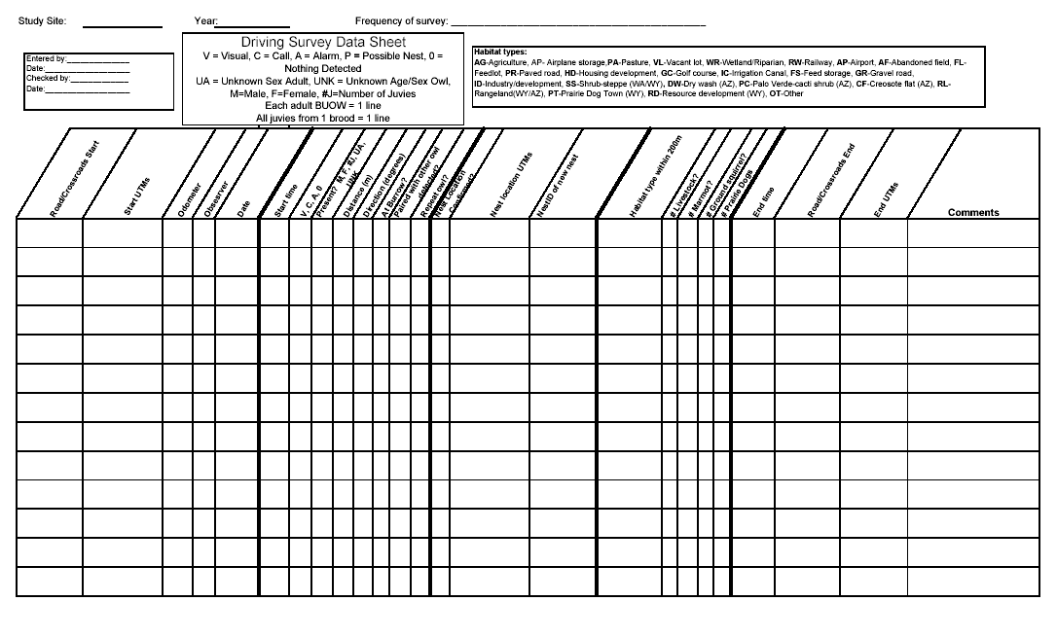
Sample datasheet for Burrowing Owl Standardized Survey

Protocol for Recording Roadside Survey Data

Field Name | Entry Example | Description
Road/Crossroads | NELSON (RDA/RDB) | Record the road on which the roadside survey was initiated Crossroads should also be recorded in parenthesis, separated by a forward slash (/). For example if you are on Nelson road between Road A and Road B the following should be recorded: Nelson (RdA/RdB). If the roadside survey start was at the intersection of two roads, both roads should be recorded separated by a slash (/).
Start UTMs | 0330868 5220296 | Record the UTMs of the location of the start of the roadside survey.
Odom | 15006 | Record the odometer reading on the vehicle used for the roadside survey. The reading should be taken at each survey point. This combined with the road information will help future surveyors locate the points without using a GPS.
Observer | CPN | The initials (three letters) of the individual who conducted the roadside survey.
Date | 15-MAR-02 | Record the date the roadside survey took place. This should be recorded as day-month (use three letter abbreviation to avoid confusion with month and day)-year.
Start Time | 0930 | The time at which the roadside survey began. The number should be recorded as a four-digit number in 24-hour time.
V, C, A, 0 | V | Record what was heard or seen during this portion of the survey. Note that each adult owl detected gets its own line at the datasheet and all juveniles detected are grouped on one line.
Sex Present | M | If owls were observed during the trial, record the sex/age of the owl in this field using the codes at the top of the roadside survey datasheet. Note that each adult owl gets its own line on the datasheet and all juveniles are grouped on one line.
Distance | 100 | If owls were observed during the survey estimate the distance to the owl and record it in this field.
Direction | 120 | If owls were observed during the survey, use a compass to determine the azimuth to the owl and record it in this field.
At Burrow? | Y | If the owls observed during the survey were at or near a burrow, put a Y (yes) in this column. If the owls were not at or near a burrow put an N (no).
Paired w/ other owl detected? | N | If the owl being referred to on the current line was detected with a mate that was also detected (this includes owls detected at previous points) record Y (yes) in this field. If no mate was detected, record N (no).
Repeat owl? | N | If the owl detected was observed from a previous point record Y (yes) in this field. If this is the first time the owl was observed during the survey, record N (no) in this field.
Nest Location Confirmed? | Y | If owls were detected, you should make an attempt to locate the owl’s burrow after the survey at that point has been completed. If you are able to locate the nest Y (yes) should be recorded in this field. If you were not able to locate the nest N (no) should be recorded. It may take several tries to find the nest. Once the nest is found be sure to change this to Y.
Nest location UTMs | 0362528 5523693 | Record the UTMs of the nest found.
Habitat Type within 200m |  | View the area within a 200m radius around the survey point and record the habitat types using the codes on the top of the roadside survey datasheet. (see Appendix I for definitions). Habitat types should be listed in descending order from the habitat type covering the most area to the habitat type covering the least area.
Livestock? | Y | Record Y (yes) if there is evidence of livestock within a 200m radius of the survey point. Electric fences, cow patties, irrigated pastures are all evidence of livestock. Record N (no) if there is no evidence of livestock.
Marmot? | Y | Record Y (yes) if there is any evidence of marmots within a 200m radius of the roadside survey point. Record N (no) if there is no evidence of marmots within 200 m.
Ground squirrel? | Y | Record Y (yes) if there is any evidence of Ground Squirrels within a 200m radius of the roadside survey point. Record N (no) if there is no evidence of Ground Squirrels within 200 m.
# of Prairiedogs | 25 | Record the number of prairie dogs seen
End Time | 15:30 | Record the time you stopped surveying this section.
Road/Crossroads End | Rd B/ Rd A | Record the location where you ended this section of the survey.
End UTMs | 0362528 5523693 | Record the UTMs where you ended the this section of the survey.
Comments |  | Record any comments.

Nest Visit Protocol

Nest visits are one of the most important and most frequent activity conducted in monitoring birds during the breeding season. By visiting the known burrows on a frequent basis you can estimate a variety of parameters including nest success, timing, and clutch size. All other activities should be combined with nest checks whenever possible.

Frequency
Visit all active nests every 3-4 days and unoccupied burrows every 7 days throughout the season. Once juveniles begin to fledge, unoccupied burrows can be visited every 10 days because the likelihood of the burrows becoming occupied at that stage is slim. Keep in mind that owls will use some of these burrows while migrating through the area, so it is still important to continue checking them. Burrows that have been unoccupied for two years in a row can be checked every 2 weeks. If there is no owl activity or sign at a previously occupied burrow, (e.g., a lack of whitewash/feces, pellets, feathers, etc.) on 3 subsequent visits (3-4 days in between) then visit the nest once a week.
If a burrow that was active goes inactive then becomes active again, return to visiting the nest every 3-4 days.
Every other visit must include a nest approach to collect pellets, etc. An effort should be made to combine other activities (trapping, detection trials, etc.) with the nest approach visit to minimize disturbance to the owls. Spend as little time as possible around the nest and area in order to prevent trampling of the burrow and mound. Also, try to avoid making obvious trails to burrows. Leaving your sign and scent around the burrow may attract predators to the burrow, so your activity at the burrow should be limited.

If you visit a nest without doing a nest approach, please record “DA” for “didn’t approach” in the comments section under each heading. If you are driving by a nest that is not scheduled for a visit but happen to observe owl activity (e.g., 2 adults standing on the mound), record your observations on the nest card and make sure to record it as a “drive by” visit in the comments section under each heading. Try to make every other nest visit at dawn or dusk.

Naming and Recording Info of Nests and Satellites
Fill out a nest card only for each pair (or resident male), not each nest burrow and each of its satellites. The idea is to monitor a pair of owls at their burrow and keep track of all satellite burrows the pair is using. All activities for this pair and the pair’s offspring are recorded on the nest card. If/when the owls start using a satellite burrow (or many), the satellite burrows are to remain on the pair’s nest card, not a new nest card for the satellite burrow. Example: Two owls from nest30 start using a satellite burrow, nest30B. When they are at nest30B, record all observations on the nest30 card, making sure to note that they are using satellite B. If a satellite burrow is being used for the first time, map the location of the satellite burrow in relation to the nest burrow so that others can easily find it in the future.

However, some burrows used as satellites will have their own nest card because the burrow may have previously been a nest of its own. For example: One year nest30 began using another satellite, nest40. Nest40 was a nest last year and already has its own nest card. If an owl uses one of the burrows that has a nest card as a satellite burrow, you still record the info on the nest burrow nest card (nest30). On the satellite burrow nest card (nest40), you only need to record that the owls from nest30 are using the burrow as a satellite.

If a satellite already named (given an A, B, C etc. designation) becomes occupied by a separate pair or you discover you were actually dealing with 2 pairs, the satellite should be renamed and get its own nest card. A note should be made on both nest cards indicating the change and on what date it occurred. For example: It is discovered that in fact there are 2 pairs using nest30 (one at A and one at B). Nest 30B should not keep this name but get a new designation such as nest31.

Using the GPS unit, make a new waypoint for each new burrow (nest and satellites) and name the waypoint after the Nest ID (the same name used on the nest card; the nest name with A, B, C for satellites). To obtain the most accurate coordinates possible, leave the unit at the burrow on “average” mode while completing the nest check. Nest names should be somewhat descriptive (use road names or area name followed by a number). This helps keep burrows organized and helps new people locate burrows that are grouped together.

Recording Info on the Front Nest Card
Fill out the front of the nest card to completion. Nest ID and Site (e.g., Ft. Carson)) as well as State are the first to be recorded. The sections for UTMs, Year, Date, Satellite burrows + UTMs, Years Occupied also need to be completed.

Be sure to record how the nest was found (H = historic, I = incidental, roadside RS = survey, WOM = word of mouth, LY = Last Year). Record the nest type the owls are using with one of the following burrow types: Artificial, Badger, Coyote, Culvert, Ground Squirrel, Irrigation trough/Badger, Irrigation trough/Unknown, Man-made, Man-made/Badger, Man-made/Coyote, Man-made/Ground Squirrel, Man-made/Marmot, Marmot, Prairie Dog, Other (if there is another animal burrow that can be identified that is not on the list) and Unknown (if it is impossible to determine what kind of burrow it is).
Badger burrows typically are flatter on the bottom of the entrance and more rounded at the top. They are usually found near the base of a slope or road cut, but can be found on level ground in Washington. Coyote burrows are fairly large and oval shaped (largest diameter from top to bottom). Marmot burrows, smaller and more round, are found among rocky outcrops or near cement, often with old marmot scat around the entrance. Man-made burrows include culverts, cement or concrete slabs, piles of dug up concrete that resemble rocky outcrops, or holes/cracks along irrigation canals or troughs. Often the man-made category needs to be combined with another category to reflect that the burrow was created or modified by an animal (e.g., a marmot dug under a cement slab).
Directions and maps will most likely need to be revised until everybody is satisfied with them, so please write lightly. Make sure all the info makes it to the front nest card so that when others go to find the burrow all the information is there and they can add the coordinates to other GPS units. As new satellites are discovered fill in their designation and UTMs in Satellites +UTMs.

Finally, for all individuals (males, females, and juveniles) that are banded, re-sighted, or re-captured at a burrow, record the color and alphanumeric code and USFWS # of the bands in appropriate space of the front nest sheet. Record this regardless of whether you banded, recapped, or just re-sighted the bird. (Note: when re-sighting birds you will not likely be able to read the USFWS band so just record it as AL).

Recording info on Page 2 of the Nest Card

Before Approaching the Nest
Observe the owls in the nest area from 125 to 300m away (depending on the sensitivity of the owls) using a spotting scope or binoculars before moving closer to read bands. Record the activity of all owls: What are they doing? Record the exact locations of males, females, and juveniles in relation to the burrow entrance (Adult / Juv act + location). Be sure to state what owls are at which burrows (e.g., M and F at Sat A, 4 juvies at nest burrow, 2 juvies at Sat D). It is extremely important to record this information so that others will know which burrows are actively being used (Active Satellites) when they visit a nest, especially when setting traps.

Record the observed stage of the nest (NS = No Sign, O = Occupied, SAT = Satellite, G = Sign, and J = Juveniles) for each visit. In other words, record what you saw not what you believe is there. Record the sex and age of each owl present based on plumage, behavior, or some other clue (never use band combos to sex the owls).
Also, record band combos (or lack thereof) for all owls present (leg/color/alpha numeric code: UNB = unbanded; NL = no legs/meaning you couldn’t see their legs to read the band; CRB = banded but couldn’t read) in Juv + bands and Adults + bands. When recording the color and alphanumeric code and USFWS # for each leg make sure you distinguish between combos that are vertical and horizontal, and be sure to include the line between the codes (record to band combos as: horizontal = Re-X3, vertical = Re-X OVER 3, vertical with a bar = Re-X BAR 3; horizontal with a bar Re-X VBAR 3).

Horizontal: | X3 | Vertical: X  3 | Vertical with bar: X  3 | Horizontal with a bar: | X 3

Record band colors with a two letter code:
AL-Aluminum (USFWS) Bk-Black Bl-Blue Br-Brown Gr-Green Ye-Yellow
Or-Orange Pi-Pink Pu-Purple Re-Red Wh-White

When trying to determine whether an owl is banded or unbanded, wait until the owl’s feet are visible. Burrowing owls have extremely long legs and it is often difficult to determine the band status without actually seeing the entire leg down to the toes. Also, they often stand on one leg and tuck the other under their body. In the beginning of the season, it is imperative to read band combinations until every owl is identified. Once identified you must try to read bands every visit. This is necessary to confirm that even owls that have been identified have not switched burrows, which they frequently do early in the season.

It may take several trips over a course of days to confirm the identity of some owls (this is in addition to scheduled nest checks). If an adult owl’s bands can not be read within an hour or so, do other nest visits in the area and periodically check back at that burrow to see if that owl has moved into a better position. It may become necessary to trap an adult owl, or set up a blind, if the adult’s bands are still unread after repeated failed attempts to resight. If a nest is active but one/or both of the adults have not had their band status confirmed after 3 days, we need to try to trap that adult.

When copulations are observed, record them under comments. When a male is observed delivering food to the burrow entrance, or adults are observed feeding young, record it under comments.

Approaching the nest

Juvenile Activity
Estimate the age (Age Est) of the oldest and youngest juvenile owls seen, using the Juvenile Ageing Guide, on each visit (don’t EVER back-date age from a previous nest visit). If you think the juvenile is between 21-23 days, record the age as 22 days. Scan the nest area and record use of all satellite burrows under Juv activity + location. Record whether juveniles Flush or Retreat to a burrow and specifically to which burrow (nest burrow, satellite A, B, C). Record any evidence of juvenile flight under Flight des (J = flight jumps or wing flapping with or without leaving the ground, W = wobbly flights, S = short flights, L = long flights).

Adult Activity
Before approaching the nest, listen for owls calling (coo-cooo, quick-quick). While approaching the nest on foot, note any owl activity as you approach and record under Adult activity + location (be sure to include satellite designation). Make sure you always keep an eye on the nest burrow. If an adult flushes from the nest burrow, keep an eye on where it goes so that you do not ‘count’ it as an owl from another nest. This is especially important at nest clusters as owls often flush toward other occupied nests (which makes differentiating between one owl and the next difficult without reading bands). Record each owl’s response to your approach (Flush or Retreat?).

Note if owl calls are given. Record whether the male or female alarm (A) calls (quick, quick, quick) or coo-cooos (C). Under F/M Behvr, record whether the owl ‘swoops’ or hovers over the observer during the nest visit by circling ‘S’. Record whether the owl ‘bobs’ after landing (‘bob’ = owl moves their body vertically up and down) by circling ‘B’ on the data sheet. They may do this several times in succession, often while giving the alarm call. Record whether adults display the ‘white-and-tall’ stance (‘white-and-tall’= owl stands completely vertical and contracts the white feathers around its face so they stand out) by circling ‘W’. Record whether the owl (usually the male) assumes the “territorial posture” by circling ‘P’ (body horizontal and feathers puffed up, with “whites” display, usually accompanied by a coo-cooo and body rotation).

At the Nest: General Nest Area Observations
In the Burrow Condition section:

Be sure to include the satellite designation for all observations!

Record whether nest lining is present, as well as what type (horse/cow manure, grass etc. Note that shredded horse/cow manure looks like shredded grass, so examine the lining closely to be sure it is identified properly.) and the quantity (N=None, S=Some, L=Lots). Record whether nest decorations (décor) are present, as well as the type and the quantity (2 pieces of tin foil, 6 pinecones). Lining usually lines the tunnel and part of the mound near the entrance and is often shredded material. Decorations are usually single items found on the mound. Be sure to record items each visit even if they have been recorded previously. The presence of scat should also be recorded. This means canine scat, which is hypothesized to be brought to the burrow by the owls to discourage predators. Marmot scat can also be present on the mound but this should not be recorded under scat. Marmot scat is a sign that marmots are frequenting that burrow, not that the owls seek it out and place it on the mound. Marmot scat should be recorded in the comments.

Type and quantity of lining and décor is recorded because they indicate nest initiation. Remove all lining
and décor at the first visit to a burrow unless the burrow was found after nest initiation. This avoids confusing lining or décor remaining from last year’s nest. On subsequent visits, remove lining or décor if it is questionable whether it is new or from an owl. If it reappears on the next visit you should not remove it. Most burrows will not require a second removal, as nest initiation will be obvious from visual sightings of the owls (or by the use of the infrared scope).

Record any evidence of fresh prey remains on or in the burrow or satellite burrow (1/2 rodent, frog guts, insects, etc.- try to ID prey items if possible). Check for pellets (circle Y if there are pellets or N for none). Collect 2-4 whole fresh pellets each time you approach a nest burrow. Pellets disintegrate at different rates dependent upon composition. Pellets consisting of mainly insect remains disintegrate quickly and easily fall apart compared to pellets consisting mainly of mammal remains. This may make it tempting to not collect pellets consisting mainly of insect remains. Please make an effort to collect pellets that are representative of the types of pellets present at the burrow. Always remove all pellets, even those not collected. When you collect pellets put them in a paper bag and write the Nest ID, the date, and how many whole pellets were collected on the bag (circle C=collected pellets on the datasheet). Make sure to record the satellite designation of where the pellets were collected.

Record the amount of new whitewash seen on the burrow mounds and perches (specify the satellite designation or specific perch if applicable) (Feces: None, Some, Lots). Do not include old whitewash on surfaces that it cannot be removed from (e.g., rock). Also, record any Burrowing Owl feathers lying around the burrow area under Feathers (circle Y=Yes or N=None). Record if there appears to be owl footprints on and around the burrow mound. There can be both adult prints (Ad Prints?) and juvenile prints (Juv Prints?) present (circle Y=Yes or N=None). Adult prints generally occur spaced out over the mound while juvenile prints occur in a specific pattern close together at the burrow entrance. Adult prints can be useful to show the presence of owls when there may be no other sign (i.e., the owls may be perching and leaving whitewash and pellets elsewhere). The presence of juvenile prints indicates when the juveniles begin emerging.
Adult Prints
Juvie Prints

Record whether any eggshell fragments or eggs were seen outside the burrow (evidence that eggs were laid).

Record any evidence of depredation (Signs of depred) or any owl death, including piles of owl feathers, predator footprints on mound, etc. Search the surrounding area within 10-30m of the burrow closely. Collect any and all remains of deceased Burrowing Owls, place them in a plastic bag, and label the bag with the Nest ID, bands, cause of death and the date. Record what type of remains were found, note where in relation to burrow the remains were found, and what may have happened on the data sheet. Often the type of remains found can determine the type of predation. The following are examples of what various predators will leave behind. Raptors: piles of feathers with little other remains; Owls: decapitate bodies; Mammals: dismembered body parts usually the wings or the legs. If banded legs are found, record band numbers. If it is a banded bird, it should also be recorded on the front nest card.

Clear all sign on each visit by scuffing away the whitewash and prints, and removing the feathers and pellets. Do the same for satellite burrows. Note that you did this on the nest card (Sign remo, circle Y=Yes or N=No). If for some reason you do not remove all sign note that sign was not removed. Make sure that for all burrow conditions you record the satellite where they were observed.

Video probe all occupied burrows once every 7 days on the approach visit. Draw a map of the tunnels and record lengths of each on the back of the front nest card during the first scoping visit to the nest so the next person to scope will have it as a reference. If there are any changes to the burrow description update the map and record it in Map updated (circle Y=Yes or N=No).

Record the Scope info. This includes what was seen (e.g., 1 egg, 4 chicks <8 days old + female) and the tunnel description (e.g., 3m, no branches). Use the Juvenile Ageing Guide to best determine the age of the chicks. Burrowing owls lay one egg an average of every 36 hours and generally have a clutch size of 7-10. Since Burrowing Owls may begin incubating after laying their first egg (usually on 4-7 eggs), the chicks will hatch asynchronously (at different times) meaning there will be chicks of various ages in the brood. Record any problems with the burrow – if you couldn’t reach the chamber, if there was loose dirt, etc.

Finally, if trapping, record whether spring traps, 2-way traps or both were used. Make sure that when you trap at a burrow you specify which burrow(s) were trapped at (nest, Sat A, B and E, etc.) and how many/age/sex were caught at each on the nest card.

If there is no sign of owl activity
If no owl activity is observed, check the burrow entrance for cobwebs. Cobwebs that are in the burrow entrance but will allow a Burrowing Owl to pass are OK, but cobwebs that would prevent an owl from passing are a sign that the burrow is not in use and need to be recorded in the comments section. Scan the nest area and record any evidence of depredation of adult or juvenile owls (owl feathers, predator foot prints on mound, etc.) as above.

Before leaving the nest area, check the nest card and make sure everything that you observed was recorded and that nothing was missed.

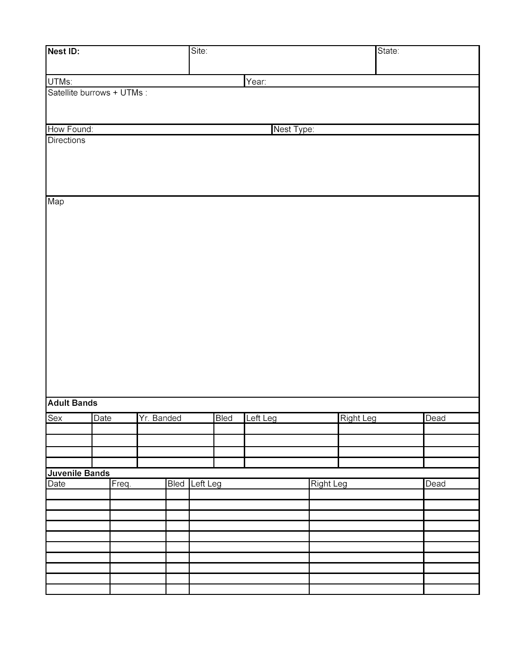
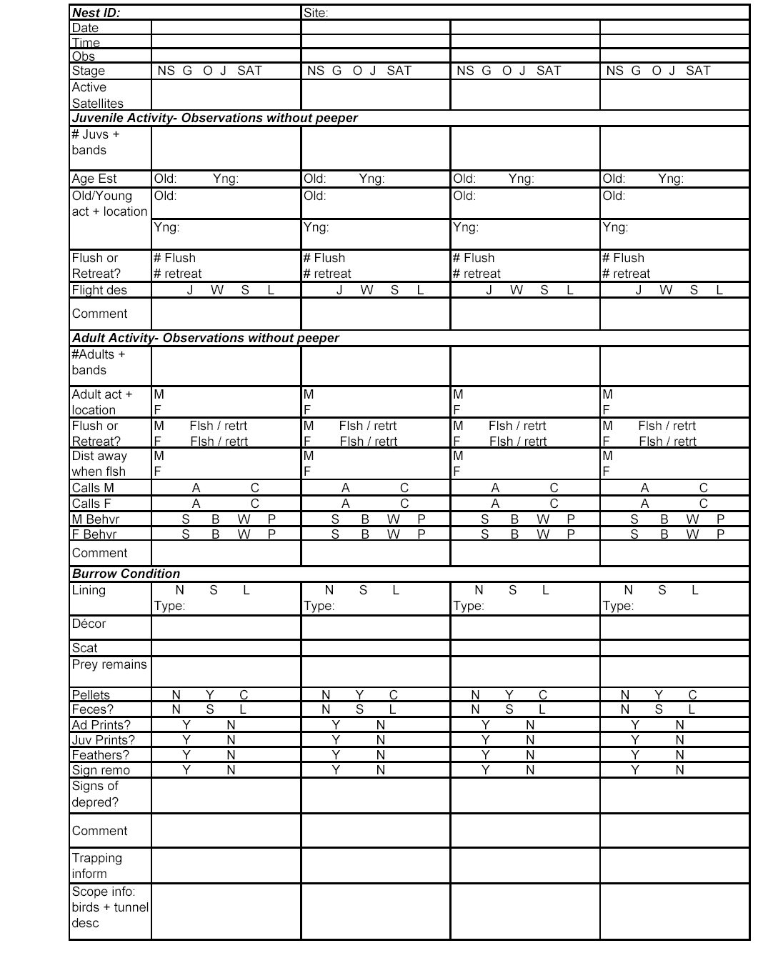

Banding Protocol

We band adult and juvenile Burrowing Owls in order to estimate population parameters such as annual survival, annual burrow fidelity, and dispersal distances. Each bird receives an aluminum USFWS band and an ACRAFT color band with a unique alphanumeric code. These bands allow individual identification of owls, which allows us to re-sight individuals and estimate population parameters. Banding is not overly stressful to the owls and allows a non-invasive way to individually identify the owl in the future. Many studies have looked at the effect of banding on survivorship and productively and have found no negative effects.
Because we use re-sight information to estimate these parameters, it is exceedingly important that band numbers and codes (the correct combination/number, color, and orientation) are recorded correctly during both banding and re-sighting. We have had field personnel make mistakes in recording band combinations each year. The models used to estimate these parameters, such as survival, are very sensitive so just a few mistakes can drastically bias our estimates. For this reason, please use the utmost care in recording the correct band combination both when banding owls and when re-sighting owls. Be as neat and clear as possible. Common mistakes are recording the number incorrectly on the USFWS band or mixing up the recording of letters and numbers on the ACRAFT bands (P & R, 5 & S, U & V, K & X, Z & 2 etc.), not recording the OVER or BAR for the orientation, or incorrectly recording which leg received which band. These mistakes take a long time to resolve and some are not resolvable.
After each bird has been banded, make sure that you double check that the leg and band combination that you just recorded on the data sheet (combination/number, color, and orientation) matches the band that you just put on the bird. To do this, the recorder must read the leg and band combo back to bander, while recorder confirms the combo is what was written on the data sheet. The bander also must confirm that the leg and color and numbers/letters are legible on the data sheet (re-write if not completely clear). Check off and date the ACRAFT band on the inventory list. Use the bands in sequential order because we are responsible for accounting for them to the National Bird Banding Laboratory and bands used out of sequence will help identify errors made in the field (although there shouldn't be any!) and resolve discrepancies.
When re-sighting a banded bird, make sure that you are 100% sure of the leg, color, combination, and orientation. If you are not 100%, you should follow what you think the band is with a “?”. Even just a color and leg can be helpful in determining what bird you have seen. Colors can be difficult to distinguish at a distance and some colors, especially purple, fade over time. You may only be able to see the leg with the USFWS band, in which case you should record which leg that band is on and return later to try to read the ACRAFT. Additionally, when recording the sex of the bird, record what sex you believe the bird is, not the way it is banded or what the last person recorded.

Trapping
There are a variety of traps and techniques used to trap Burrowing Owls. The most common are the two-way trap and the spring trap. The two-way trap is a box trap with a one-way door on either side. The trap is placed in the burrow entrance and catches the owl as it goes in or out of the burrow. The advantages of this trap are that it can usually be left unattended for longer periods of time (2 hour max) and it can catch multiple owls at the same time. The spring trap uses a rodent (gerbil or mouse) in a cage to attract the owl. When the owl attempts to capture the rodent, the trap is tripped and a mesh dome springs over the owl. The spring trap is usually set in front of the burrow or on a level surface in close proximity to the burrow. The spring trap should not be left unattended for longer than 15 minutes at a time. When an owl is caught in the spring trap, the trapper should be as quick as possible getting to the trap to reduce the risk of injury to owl.

Both traps are very effective but can be used more efficiently at different times of the day and year. Early in the season spring traps are effective as owls are not always using one burrow and may be shy of going through a two-way. Also, food is less abundant early in the season making the rodent much more attractive. As owls begin to initiate nests, two-ways become very effective. Often the two-way works best when set a half-hour to an hour before dark and is checked about an hour after dark (although both the spring trap and the two way are effective at any time of day). Note: Female owls who are known to be laying should not be trapped as they may lay an egg in the trap. When juvenile owls begin to emerge two-way traps are very effective. It is very important to try to trap juveniles shortly after they emerge (age 20-25 days), as they are much easier to trap at a young age. However, trapping juveniles too young (less than 20 days) is not productive because their tarsus is too short to receive an ACRAFT band, which requires them to be recaptured for the ACRAFT to be added. As juveniles get older, spring traps may become more effective. If juveniles have not been trapped at a nest it is very important to keep trying a variety of methods.

It is important to try a variety of trapping techniques on individuals who are not falling for the usual tricks. Banding all the adult owls observed is an important part of the study, and owls that are not trapped soon after their first observation may leave without ever being banded. It is often effective to set a two-way in the burrow entrance upside down, covering the doors with dirt, for a period of time before properly setting the two-way. This allows the owl to go in and out of the burrow and trap, making the owl accustomed to the trap’s presence. When the trap is flipped over the owl will not be shy and will normally walk into the trap. Other techniques include mist nets accompanied by broadcast calls and/or a stuffed burrowing or great horned owl, or noose carpets. If you have made 3 attempts with conventional spring trap and/or two-way methods some of these techniques should be attempted to increase your chances of catching the owl.

Be careful when setting traps on the edge of agricultural areas or in horse or cow pastures. Livestock are often curious and farmers on equipment may not see traps. If you suspect the trap could be damaged or worse, an owl be killed in a trap by livestock or farm equipment, monitor the trap from a distance or trap at a later date.

Handling and Banding
To avoid injuring the owl, be careful when removing it from any trap. This may require you to pry open feet or untangle legs, wings or head from the trap. After removing the owl, place it in a bird bag or sock. While banding and performing measurements, always pay close attention to the bird. Placing the owl in a sock during the actual banding and measuring makes handling easier, reduces stress for the owl, and reduces the chance of escape and injury. Banding and all measurements will be demonstrated in the field as well as described in attached descriptions and keys. Try to minimize handling time to reduce any stress to the owl.

Each time you catch or re-catch a bird, determine its sex, weigh it, and estimate its age (juveniles only). This allows you to look at the change of weight with age over the breeding season and between breeding seasons. Morphological measurements (tail length, meta-tarsus, wing chord) are made on adult birds that allow comparison of body size between sexes and sites. Age estimations are very important in determining success of nests and feather emergence is helpful in determining age. Follow the codes at the top of the banding sheet.

Protocol for Recording Bands

Field Name | Entry Example | Description
Left Leg | Pu-G OVER 2  Pu-CRB | Record the band number and color of the band on the left leg. USFWS bands should be recorded as they appear on the band including the hyphen.  For Acraft bands record the color abbreviation, followed by a hyphen (-), followed by the alphanumeric code. Alphanumeric codes should be recorded as follows.  Horizontal: AS; looks like  Vertical: A OVER S; looks like  Vertical separated by a line: A BAR S; looks like  Horizontal separated by a line: A VBAR S; looks like  Please be extremely careful when recording Acraft numbers and orientations. Record all band numbers clearly, anything that is unclear should be re-written.
  A
  S
  A
  S
  A | S
  A | S
Right Leg | Al: 0844-12456  Al | Record the band number and color of the band on the right leg. See above.

Band Colors (Banding and Nest Cards)
AL | Aluminum | Re | Red | Bk | Black
Pu | Purple | Bl | Blue | Gr | Green
Or | Orange | Br | Brown

Other situations

M - nl – a male, but you could not see his legs to determine if he is banded or not.
M - crb – a banded male, but you cannot read the bands on either leg.
M - unb – an unbanded male.
M - L:Re A OVER ? – A male with an Acraft on the left leg, but you cannot read the lower number on the band.

Guide to reporting ACRAFT bands

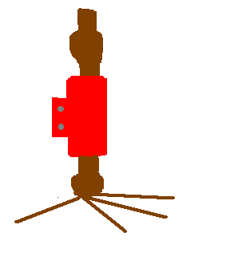
E M
E M
E M
Re–EM
(This is the correct orientation for this type of band: foot to body)
Re–EM (body to foot)
(But sometimes bands are placed this way by mistake; please make a note that the band is oriented body to foot)
Re–E VBAR M
(This is the correct orientation for this type of band: foot to body. Sometimes they are placed body to foot by mistake. If so, please make a note of it.)

E
M
E
M
Re–E OVER M
Re–E BAR M

Protocol for Recording Banding Data

Field Name | Entry Example | Description
NestID | STEE3A | Record the nestid (including satellite designation if applicable) for where the captured owl is from. This should be the nest or natal burrow and is not necessarily the same as the burrow at which the bird was captured. This field must be recorded for recaptures.
Burrow caught at if not nest | STEE5 | If the owl was not caught at the natal burrow record the burrow where the owl was captured (include satellite designation if applicable). This field must be recorded for recaptures.
Date | 10-Jun-03 | Record the date for when the banding took place. This should be recorded as day-month (use three letter abbreviation to avoid confusion with month and day)-year. This field must be recorded for recaptures.
Observer | CPN | Record the initials (three letters) of the individual who actually banded the owl and took the measurements. Only one set of initials should be recorded. This field must be recorded for recaptures.
Left Leg | 0844-39782 | The band number and color of the band placed on the left leg. USFWS bands should be recorded as they appear on the band including the hyphen. For acraft bands record the color abbreviation, followed by a hyphen (-), followed by the alphanumeric code. Alphanumeric codes should be recorded as follows.  Horizontal: AS  Vertical: A or A OVER S  S  Separated by a line: A or A BAR S  S  Be sure to triple check all bands before releasing the bird. Record all band numbers clearly, anything that is unclear should be re-written. This field must be recorded for recaptures.
Right Leg | Bl-2 OVER 3 | The band number and color of the band placed on the right leg. See the above description for the proper format. This field must be recorded for recaptures.
Re-cap? | Y | Record whether the owl captured is a recapture or has been captured for the first time. Put a Y (yes) in the field if the owl is a recapture and N (no) if the owl is not a recapture. Record the information for all data fields in caps when dealing with recaptures.
Bird-Bag Wght | 190 | Record the combined weight (in grams) of the bird and the bag or sock the bird was weighed in. This must be recorded for adult recaptures.
Bag Wght | 2 | Record the weight (in grams) of the sock or bag the bird was weighed in. This field must be recorded for adult recaptures.
Sex | M | Record the sex/age (M, F, J) of the owl captured. We do not attempt to sex juvenile owls, we simply record them as J. This must be recorded for recaptures.
How Sexed | PL | Record the method used to sex the owl. Accepted methods are listed at the top of the banding datasheet. This only needs to be recorded for adult owls and must be recorded for recaptures.
Brood Patch? | 0 | Examine the owl for signs of a brood patch (see Appendix III for brood patch picture). Using one of the codes at the top of the banding datasheet, record the stage of the owl’s brood patch. Note only adult female Burrowing Owls will have a brood patch.
Adult Left Wing | 180 | Use the method shown in Appendix II to measure the owl’s left wing chord length. Record the measurement in millimeters (mm). This measurement is only taken on adult owls.
Adult Right Wing | 178 | Use the method shown in Appendix II to measure the owl’s right wing chord length. Record the measurement in millimeters (mm). This measurement is only taken on adult owls.
Adult Left Meta-tarsus | 72 | Using the method shown in Appendix II measure the owl’s left meta-tarsus. Record the measurement in millimeters (mm). This measurement is only taken on adult owls.
Adult Right Meta-tarsus | 68 | Using the method shown in Appendix II measure the owl’s right meta-tarsus. Record the measurement in millimeters (mm). This measurement is only taken on adult owls.
Juvie Age Range | 24-27 | Using the guide to aging juvenile Burrowing Owls in Appendix V record an age for the owl. This is only recorded for juvenile owls and must be recorded for recaptures.
# of Feathers Collected? | Y | Record the number of feather collected from each body region.
Wing Pics? | Y | Take a picture of the outside of the owl’s out stretched wing. Be sure the picture includes a piece of paper with the owl’s acraft band written on it. Take a picture of both wings. Pictures are only taken on adult owls.
Blood Taken? | Y | Take blood from the owl’s brachial vein and record Y (yes) in this field. Someone who is experienced taking blood should show you and watch you take blood for the first few times. Do not attempt to take blood if you are not completely confident you know what you are doing. This is an intrusive procedure and could cause serious injury or infection to the owl. Record N (no) in this field if you did not take blood.
Comments |  | Any comments applicable to the banding data should be entered in this field (injuries to bird, bands put on upside down or on the wrong legs, etc).

Morphological Measurements of Burrowing Owls

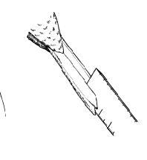
How to Take Tail Measurements of Burrowing Owls

- Gently separate the tail feathers in approximately the middle of the tail.
- Insert the ruler perpendicular to the axis of the tail feathers (if the owl were standing the ruler would be vertical) until it touches the body where the tail feathers originate.
- Be sure the ruler is held parallel to the length of the feathers and read the measurement at the tip of the longest feather.
- Record the measurement in millimeters (mm).

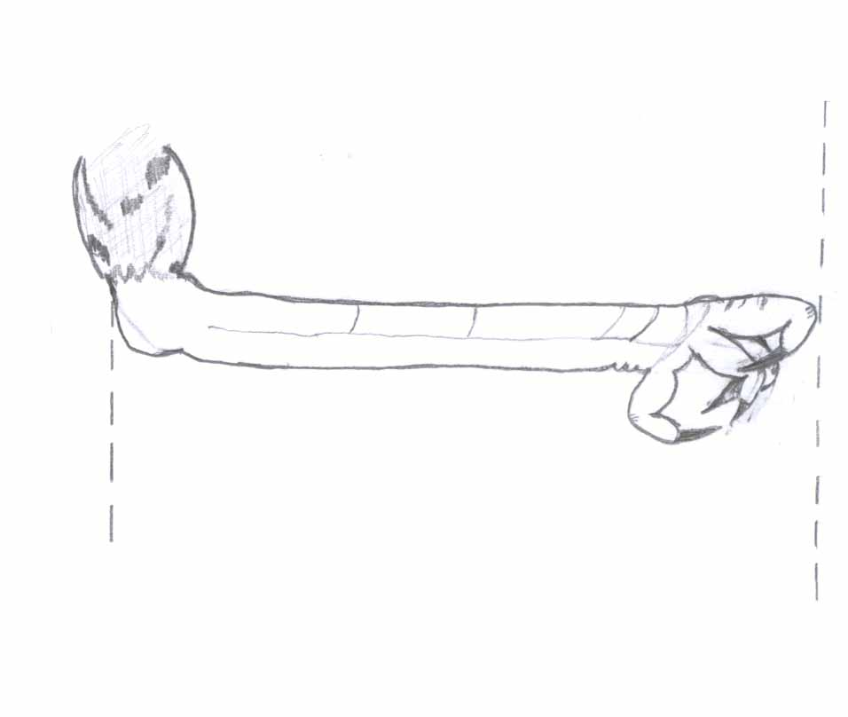
How to Measure Metatarsal Length of Burrowing Owls
longest toe

tarsus
knuckle
thigh
measurement

- Bend the leg to form a 90 degree angle with the thigh and tarsus.
- Bend the longest toe (third digit or middle of the three front digits) at the knuckle (owls will usually have done this themselves as they normally clench their feet closed while being handled).
- Extend the bent toe to form a straight line with the toe and the tarsus
- Measure from the back of the joint between the thigh and tarsus to the knuckle of the extended toe.
- Record the measurement in millimeters (mm).
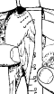
How to Measure Wing Chord (unflattened wing) Length of Burrowing Owls

- Let the wing lay naturally on the bird’s side.
- Slide the ruler under the wing with the lip of the ruler on the joint above the primaries. (If you are not using a universal wing ruler be sure to use the correct ruler for the side you are measuring. Marking the rulers “left” and “right” will help stop mistakes).
- Holding the ruler against the joint, move the tip of the longest feather onto the ruler. Let the wing lay naturally on the ruler and record the measurement.
- Record the measurement in millimeters (mm).

Note: Be sure not to flatten the wing on the ruler. This is a different measurement and will cause inflated results in wing chord length.

Brood Patch Picture

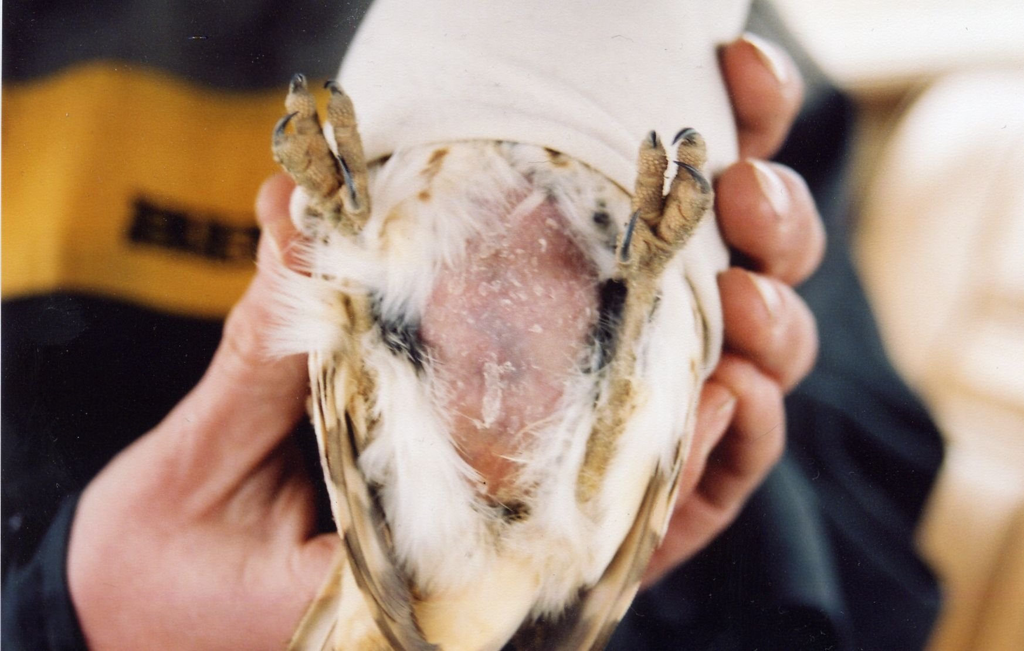
Female Burrowing Owl with large vascularized brood patch. Note the blue/purple coloration in the middle of the brood patch. The intensity of the color will vary but the presence of the blue/purple coloration is key to recognizing a vascularized brood patch.

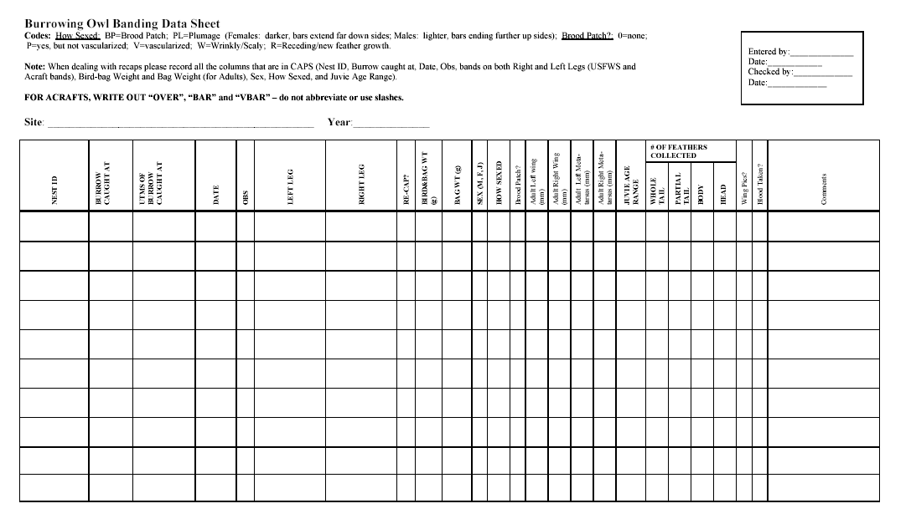

Protocol for Recording Trapping Log Data

Field Name | Entry Example | Description
NestID | STEE3A | Record the nestid including the satellite designation, if applicable, for the burrow where the trap was set.
Date | 17-MAR-02 | Record the date when the trap was set. This should be recorded as day-month (use three letter abbreviation to avoid confusion with month and day)-year.
Observer | CPN | Record the initials (three letters) of all the individuals involved in the trapping process.
Start Time | 0730 | Record the time when the trap was set. Use 4-digit military (24 hour) time.
End Time | 1310 | Record the time trapping activities stopped. Use 4-digit military (24 hour) time.
Trap Type | 2W | Record the trap type used. Abbreviations for the traps types are: 2W: two way, ST: spring trap, NC: noose carpet, MN: mist net.
Time Chck’d | 0830 | Record the time (4-digit military format) each time the trap is checked.
# Caught | 2 | Record the number of owls caught for each time the trap is checked.
Comments | Banded 1 J and recaptured F | Record any comments relevant to the trapping activities which were not recorded above. Record the number and sex/age (M, F or J), the leg (L or R) and the acraft alphanumeric code for all the owls captured. Also be sure to note if any of the owls were recaptures.

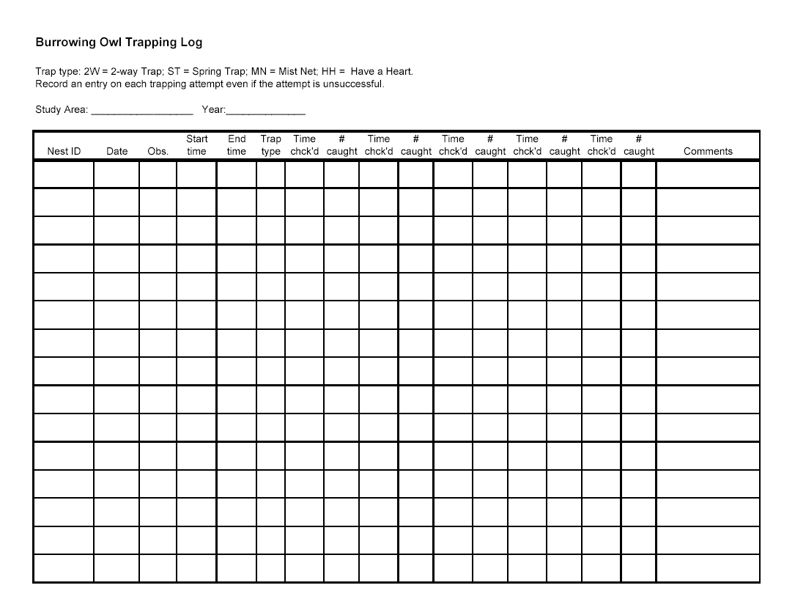

Quick Reference for Codes and Acronyms on Datasheets

Nest Information
How Nests Were Found (Front Nest Cards)
H | Historic | I | Incidental
PDTS  LY | Prairie dog town surveys  Last year | RS | Roadside survey
WOM | Word of mouth

Substrate (Front Nest Card)
Artificial Badger Coyote Marmot Ground Squirrel Prairie Dog Man made Man made/Badger Man made/Ground Squirrel Man made/Marmot Man made/Coyote Irrigation trough/Unknown Irrigation trough/ Badger Culvert Other

Stages (Nest Cards)
NS | No sign | G | Sign
O | Occupied | J | Juveniles
SAT | Satellite
* Record the stage as you observed it, not what you believe the stage to be based on previous visits

Visit Types (Nest Cards)
DA | Didn’t approach the nest | Drive by | Observed birds at a nest incidentally on route to another location
* Visit type descriptions need to be placed in the all the comment sections when applicable.

Banding information
Band Colors (Banding and Nest Cards)
AL | Aluminum | Re | Red | Ye | Yellow
Pi | Pink | Bl | Blue | Gr | Green
Or | Orange | Wh | White | Bk | Black

Banded Status (Banding and Nest Cards)
UNB | Unbanded | NL | No legs (could not tell if banded)
CRB | Banded but couldn’t read the band
All resighted bands should be recorded in the following manner:
Sex (M or F or J) : Leg (R or L) : Color (see above) – Alphanumeric code (written as it appears on the band)

Horizontal: AS
Vertical: A or A OVER S
S
Separated by a line: A or A BAR S

S

Land-use and habitat types (Roadside Surveys)
ag | Agriculture | Gr | Gravel road | pa | Pasture
Af | Abandoned field | gc | Golf course | Pc | Paloverde-cacti scrub
ap | Airport | hd | Housing development | pr | Paved road
cf | Creosote flat | Ic | Irrigation canal | rw | Railway
dw | Dry wash | Id | Industry/development | Ss | Shrub steppe
Fl | Feedlot | Ig | Invaded grassland | vl | Vacant lot
Fs | Feed storage | Ot | Other | wr | Wetland/riparian

